Purulent SSTI
- Folliculitis: Infections at the superficial layer that involve inflammation of the hair follicle. Only the epidermal layer contains pus.
- Furuncles: Infections that spread to the subcutaneous tissue from a hair follicle. Containing purulent material.
- Carbuncles: A collection of coalesced furuncles that extends into the subcutaneous tissue.
- Most common cause: S. aureus
  - Other causes: P. aeruginosa and Candida
Nonpharmacologic Treatment
- Moist compresses for non-open wounds, proper wound care, anti-inflammatory agents/analgesics
Pharmacologic Treatment

*Systemic signs of infection are defined as tachypnea >24 breath per minute, tachycardia >90 beats per minute, WBC >14K or <400 cells/µL, temperature >38 C or <36 C, hypotension.

Non-Purulent SSTI
 | Erysipelas | Cellulitis | Necrotizing Infection
Common pathogens | S. Pyogenes | S. pyogenes and S. aureus | Aerobes (including MRSA and streptococcal species) and anaerobes (clostridial species).
Risk factors | - Infants/young children  - Elderly  - patients with nephrotic syndrome | - Wound from trauma, ulcer, surgery, or abrasion | - Diabetes  - Peripheral vascular disease  - Neoplasm
Clinical Presentation | Symptoms:  - Flu-like symptoms  Signs:  - Lesion is erythematous and edematous with lymphatic streaking  - Raised boarder | Symptoms:  - Area is warm to touch/painful  - Fever/chills  - Hypotensive, dehydrated, AMS (severe cases)  Signs:  - Non-elevated lesions  - Erythema, warmth, edema  - Inflammation with minimal or no necrosis | Symptoms:  - Fever/chills  - painful  - Failure to antibiotic therapy  Signs:  - Rapid progression (medical emergency)  - Hot, erythematous, swollen  - Shiny, tender, hard, wooden feel
Antibiotic therapy | Mild/Moderate:  - Procaine Penicillin G IM x 1 dose  - Penicillin VK PO  Severe:  - Aqueous Penicillin G IV x 2-3 days, then switch to PO penicillin VK  Allergy: Clindamycin (PO/IV) | Mild (PO):  - Penicillin VK or cephalosporin or dicloxacillin or clindamycin  Moderate (IV):  - Penicillin G or ceftriaxone or cefazolin or clindamycin  Severe (IV):  - Vancomycin and piperacillin/tazobactam | Surgical intervention and debridement  Empiric therapy:  - vancomycin and piperacillin/tazobactam or carbapenem and clindamycin  - MRSA: Vancomycin  - Streptococcal or clostridial species: Penicillin G and clindamycin
Duration of therapy | 7-10 days | Mild cases: 5 days  Moderate-Severe Cases: 10 days | Antibiotics are given until no surgical intervention is needed, clinical improvement, and patient is afebrile for at least 2 days.
 | 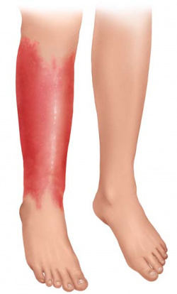 | 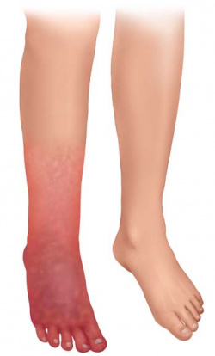 | 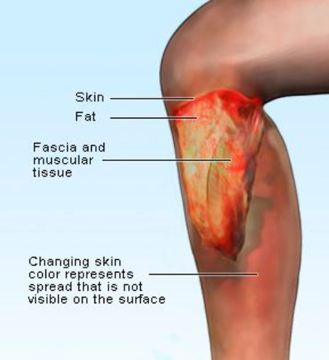

- Fish DN. Chapter 133: Skin and Soft Tissue Infections. In: DiPiro JT, Yee GC, Posey ML, Haines ST, Nolin TD, Ellingrod VL, eds. Pharmacotherapy: A Pathophysiologic Approach. 12th ed. New York, NY: McGraw-Hill; 2021. https://accesspharmacy-mhmedical-com.maproxy.palni.edu/content.aspx?sectionid=268015487&bookid=3097&Resultclick=2. Accessed July 09, 2023.
- Skin Infections. Centers for Disease Control and Prevention. Available at: https://www.cdc.gov/antibiotic-use/skin-infections.html. Accessed July 09, 2023.
- Stevens DL, Bisno AL, Chambers HF, et al. Practice guidelines for the diagnosis and management of skin and soft tissue infections: 2014 update by the Infectious Diseases Society of America. Clin Infect Dis. 2014; 59(2): e10-e52. doi:10.1093/cid/ciu444.
- Multiple-Entries. Lexi-Drugs. Lexi-Comp Online. Lexi-Comp, Inc. Hudson, OH. Available
at: http://online.lexi.com/crlonline. Accessed July 09th, 2023.
- Erysipelas and cellulitis. informedhealth.org. (n.d.-a). https://www.informedhealth.org/erysipelas-and-cellulitis.html

